|  |  |
| --- | --- |
| Date | 20 September 2022 |
| Team ID | PNT2022TMID45267 |
| Project Name | Global Sales Data Analytics |

**Country wise sales Vs profit using word cloud**

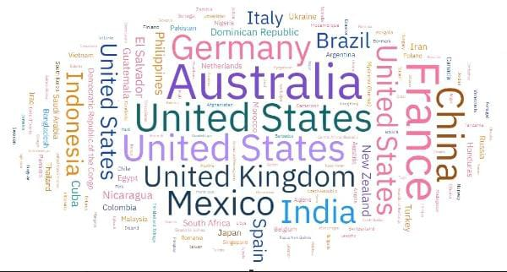

**The sales process of any business generates a considerable amount of data. Particularly among those with outside, traveling sales teams. From customer metrics to information about lead generation, the average sales manager has a lot of metrics and key performance indicators at their fingertips.**

**However, gathering, analyzing and leveraging sales data can be a complex task without the right expertise and tools in place. Managers need a way to keep track of sales territories and spot merging trends.**

**When done successfully, sales data analysis can help you balance workloads and opportunities among your sales reps, successfully meet service level agreements, and drive revenue growth for your business.**

**What is sales data analysis?**

**Its Ultimate Guide to Sales Metrics, HubSpot identified three levels that sales metrics could be applied to: a single sales rep, the wider sales team, or the company as a whole.**

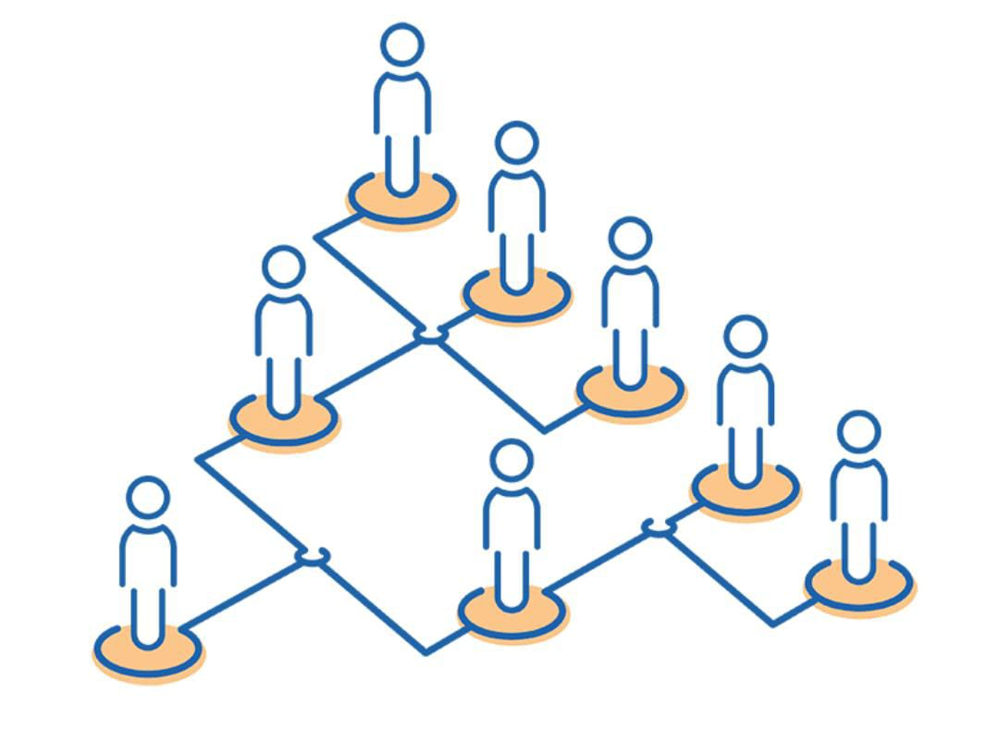

1. **Total revenue**
2. **Revenue per sale**
3. **Revenue by product**
4. **Revenue by territory**
5. **Sales by lead source and location**
6. **Revenue split between new and existing customers**
7. **Customer Lifetime Value**
8. **Sales team quotas**

**SMART is a widely-used model for incentives and performance measurement, not just in sales. It helps to avoid goals that are vague or impossible to hit, which only serves to demotivate your team.**

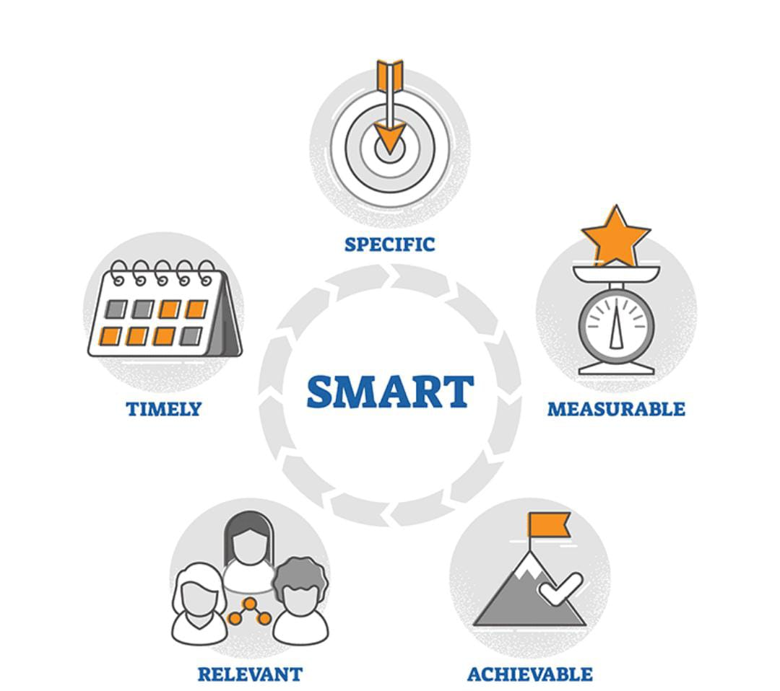

**Territories based on their sales data analysis have reported a 2-7% increase in sales numbers, proving the effectiveness of this approach.**



